**Avanti Recue Project Update**

**Engine preparation**

**We ran the Avanti engine one last time on the engine stand, changed oil and filter, then began removing external chrome and parts with Al and Lou and Rich.**

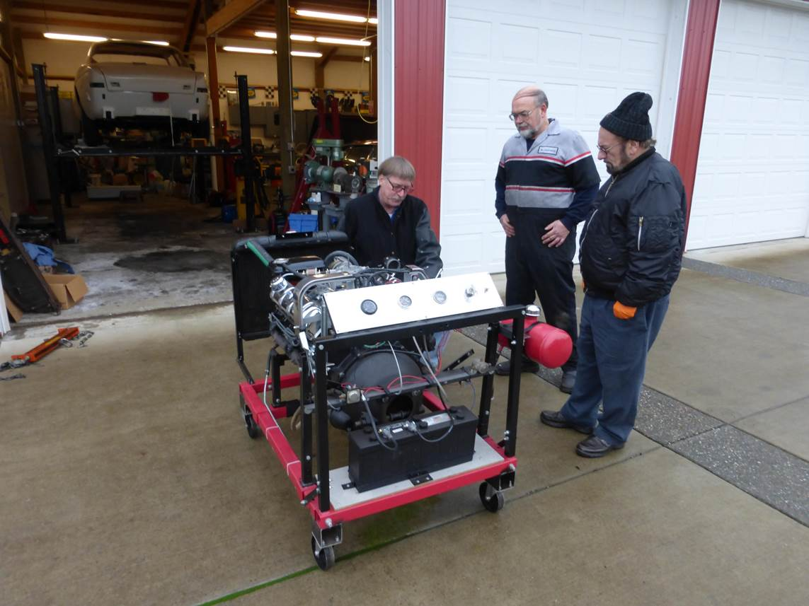

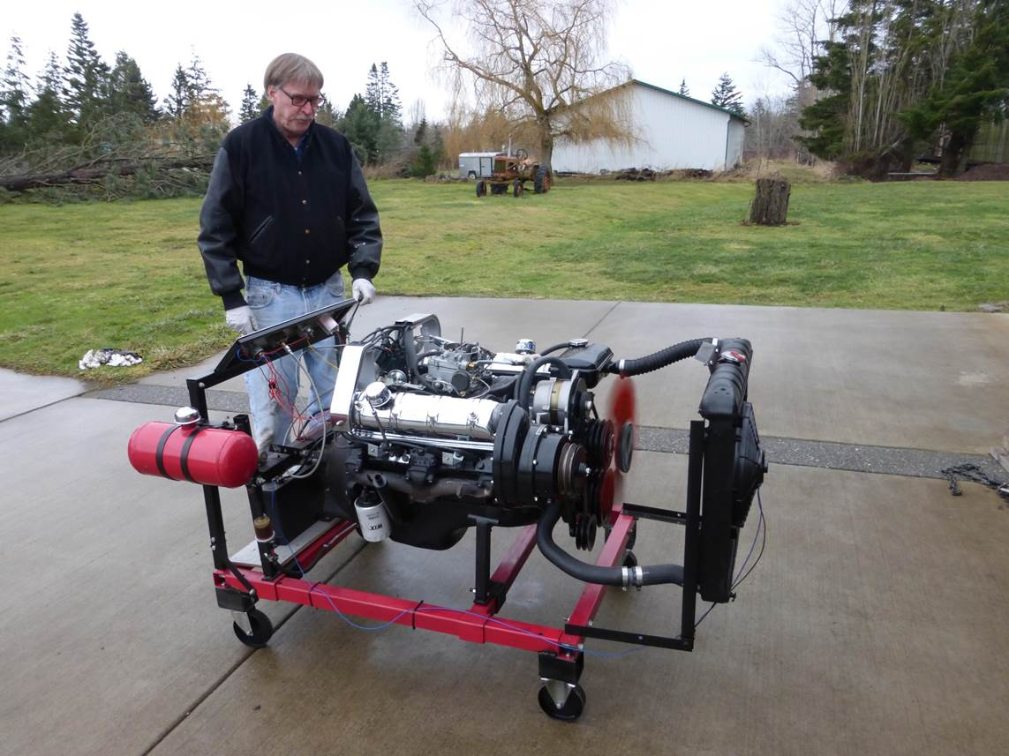

**We prepared it for installation in the car by draining the antifreeze etc., so it will be ready to install.**

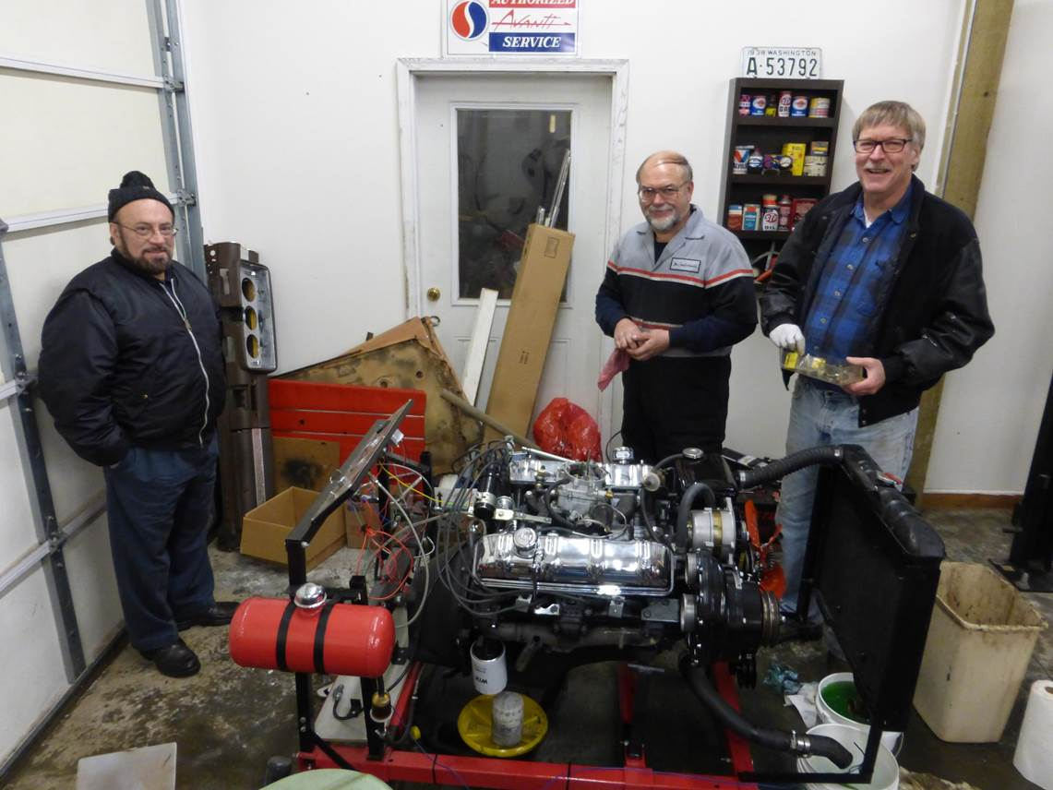

**The floor was a mess so Lou brought up some commercial floor cleaner and mop the following weekend.**

**It was so cold in the shop, we had to stop and install an electric heater.**

**Lou installed new seals in the steering ram and we installed it. (sorry no pictures this weekend)**

**Al took the front sway bar and cleaned it up and painted it, then new sway bar bushings were installed.**

**Then Brian Curtis came over for several days to help.  The front sway bar got installed.**

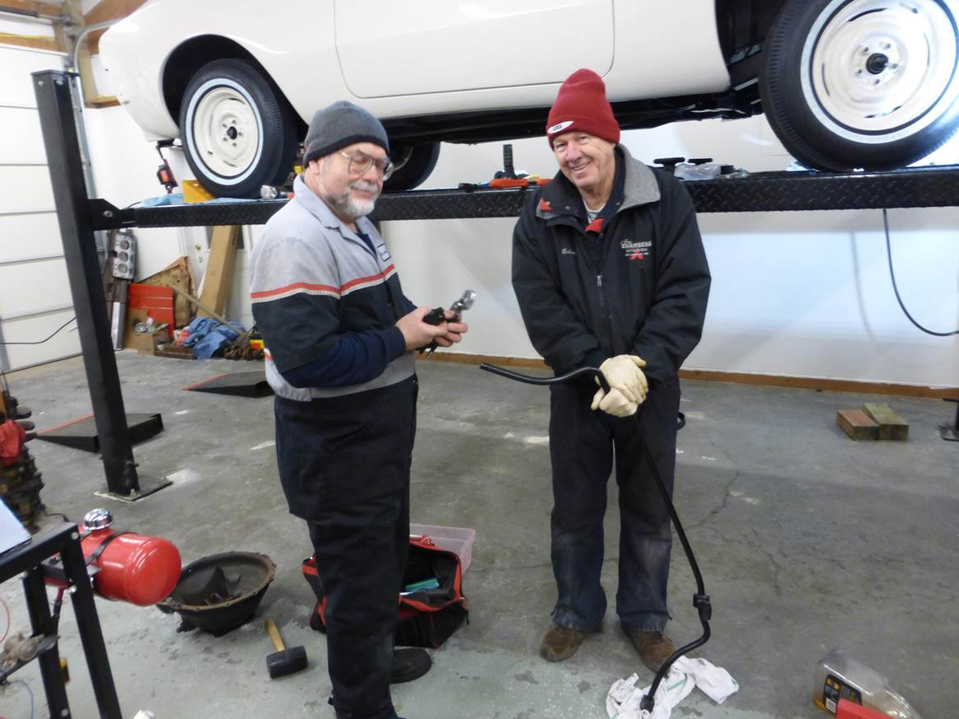

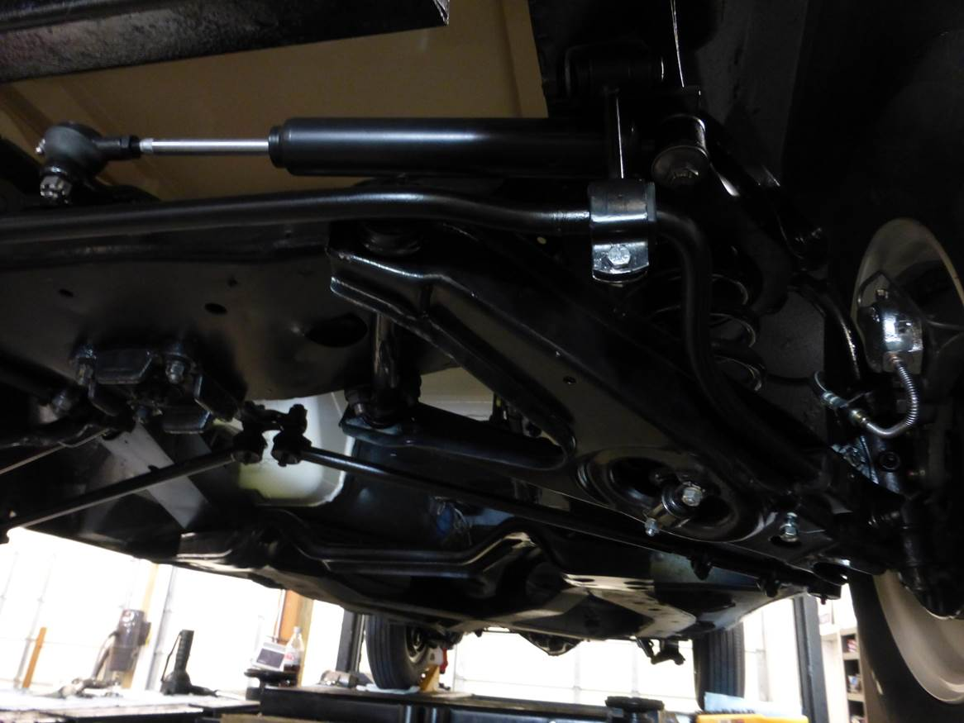

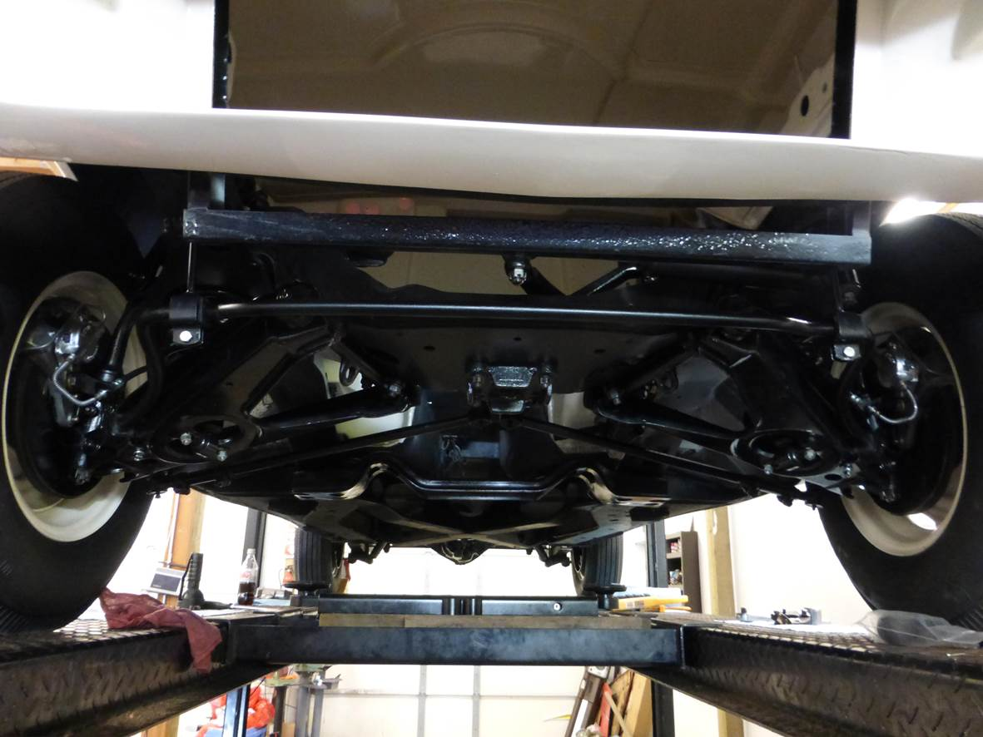

**Then we removed the engine bellhousing and installed a new clutch, pressure plate, throw-out bearing and pilot bearing in the flywheel.**

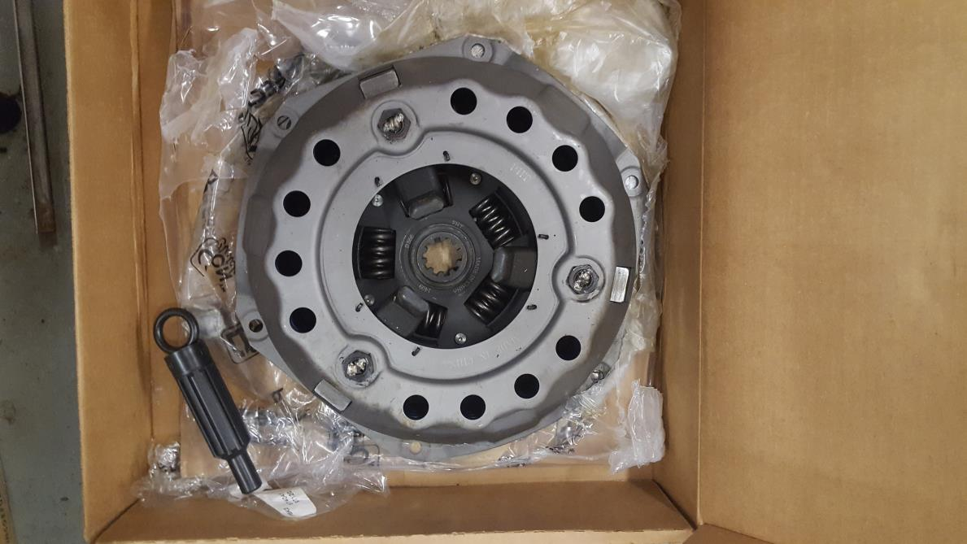

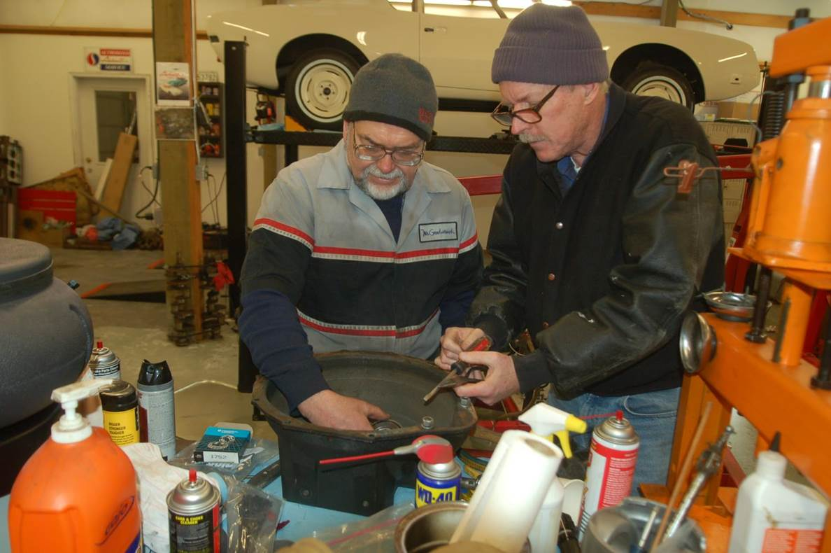

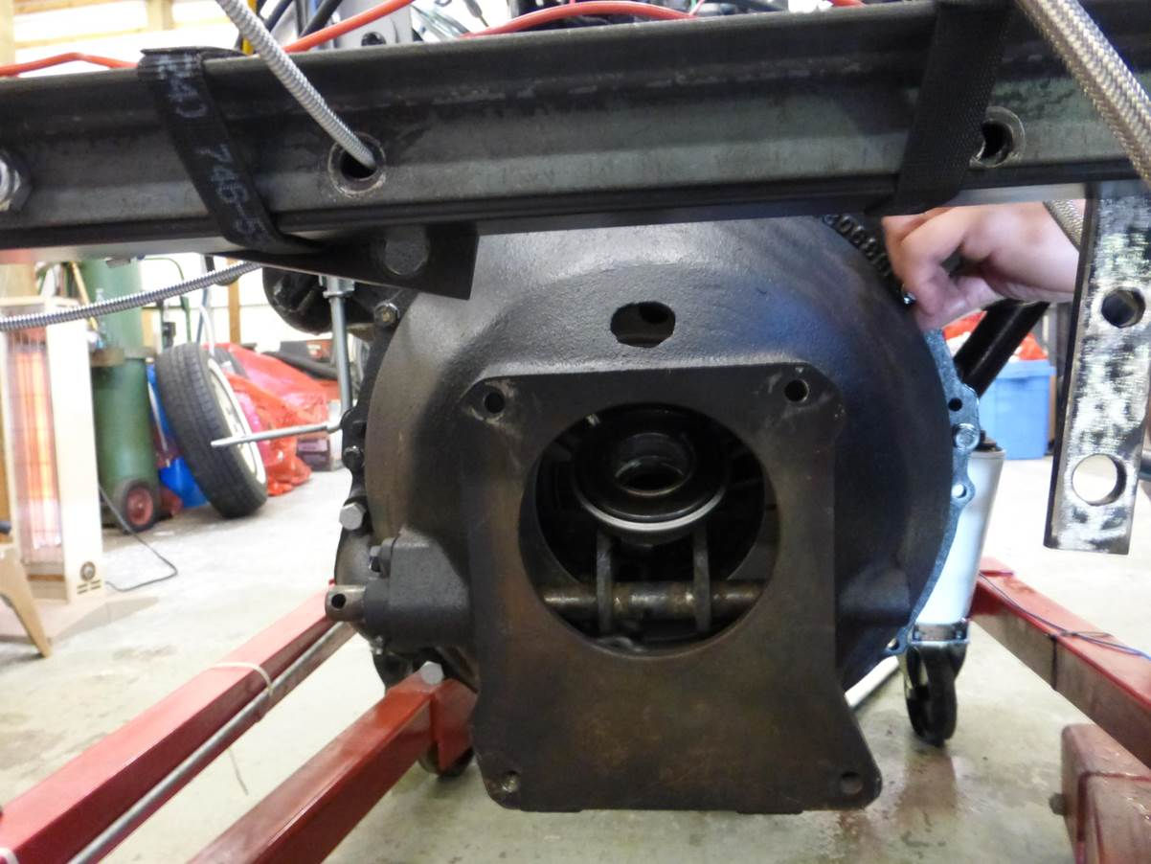

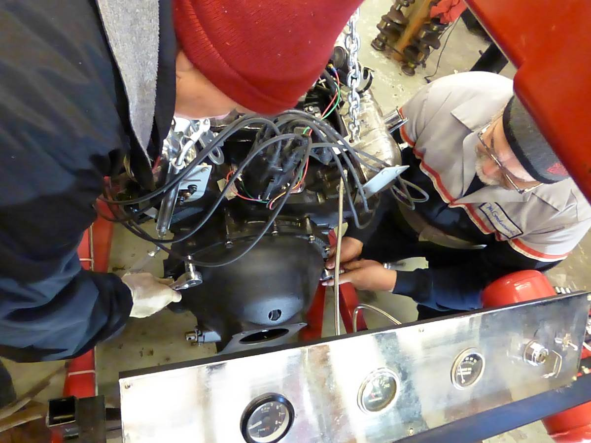

**I will be in San Francisco for the next 2 weekends, but Lou and Al will be here the weekend after for the next work party.**

**We want Brian and a few others to be here for the engine installation since he helped the most on the engine assembly. He can’t do it on Feb 11th, so we will begin on the interior then and install the engine with Brian on the 18th.**

**Thanks,**

**James**