**Avanti update 12/5/2016**

**We finally got the Avanti Steering Box parts needed, then rebuilt and installed the box.**

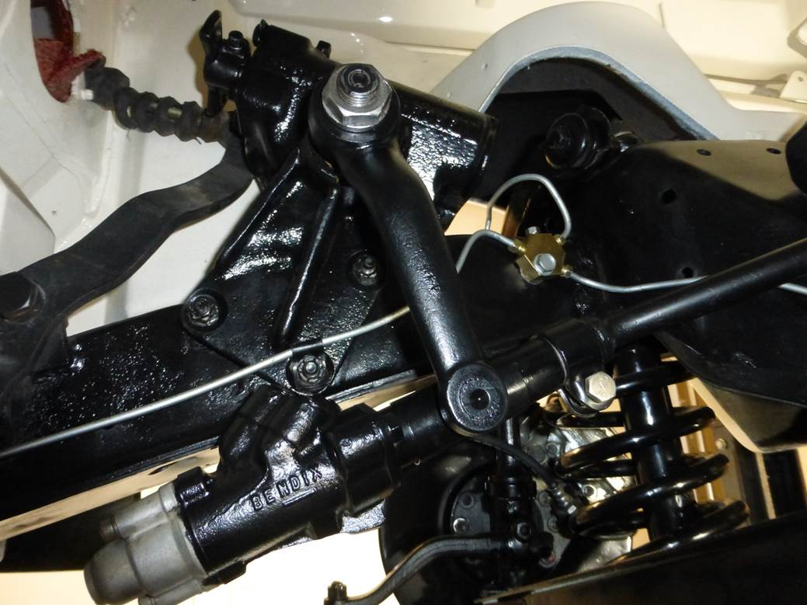

**The parts to rebuild the Ross box have become very hard to find, but it should be good for the next hundred years now.**

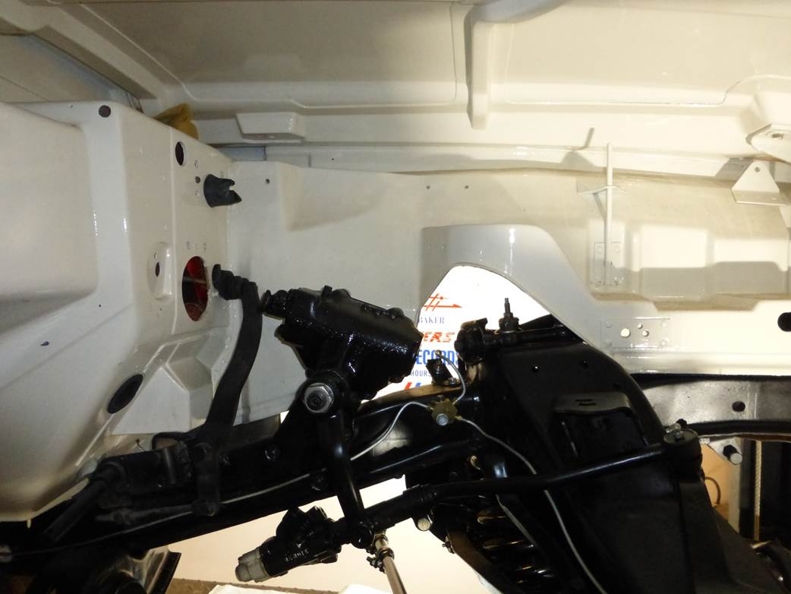

**It was missing the correct Pitman Arm for power steering that goes from the box to the control valve below it, so we installed a correct one.**

**It was also missing a control valve, so we also installed a Rebuilt  Control Valve.**

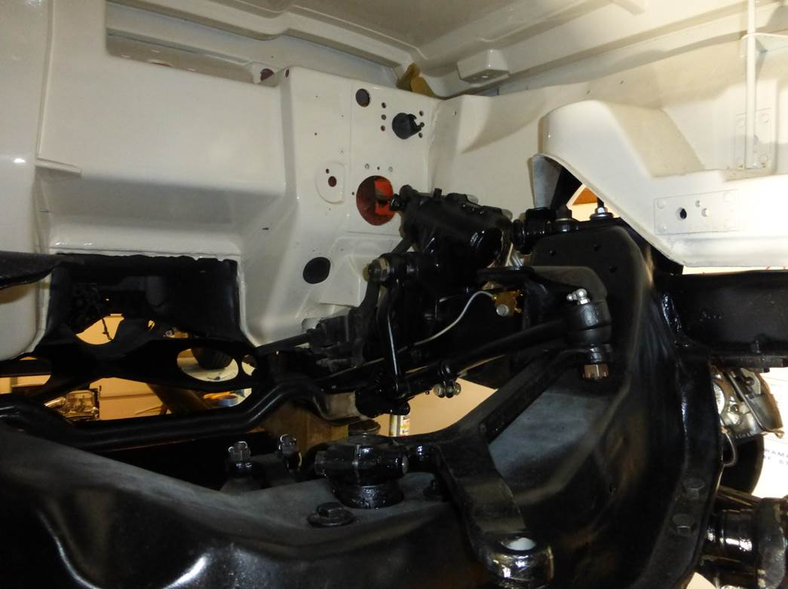

**The control valve under the steering box needed a Reach Rod that we installed and connected to the bellcrank.**

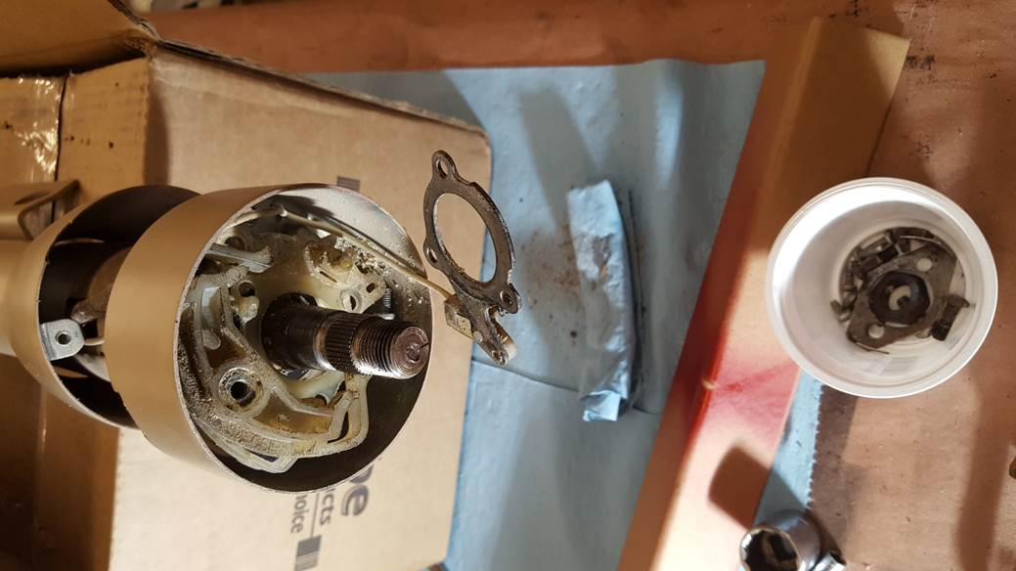

**The Steering Column got disassembled and Replaced Bushing that was shot allowing the lower end to flop around.**

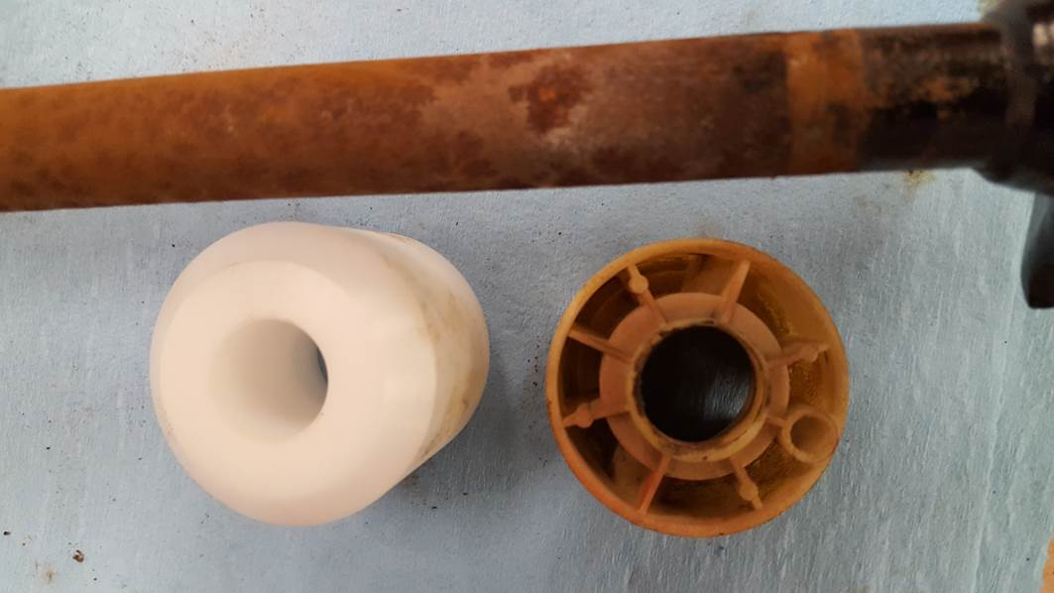

**The bushing looks a bit different than original, but is stronger and should be good for the next 200 years.**

**If you look closely at 1 o-clock in center of old bushing on right, you can see where inner collar wore thin.**

**I also installed a new chrome Turn Signal Arm and the center shaft rust removed.**

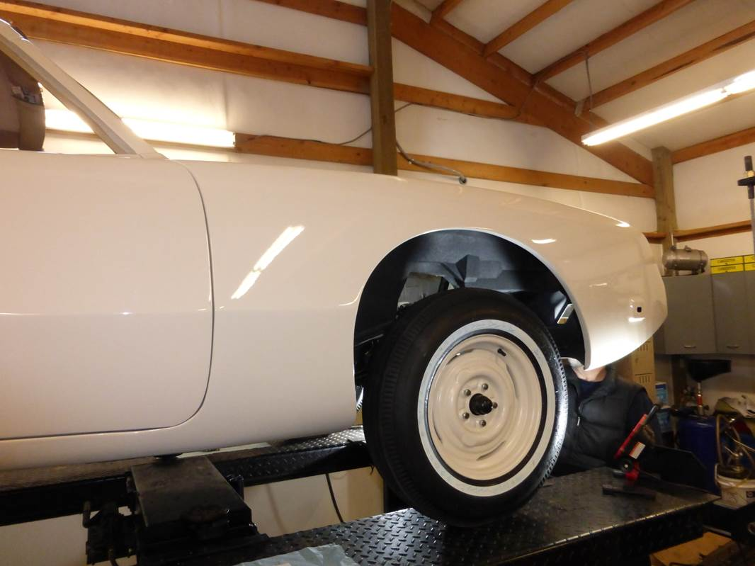

**With the new front tires on, it’s getting ready to install the engine and transmission soon.**

